- 2 types of tokens should be there: access token (short validity; around 10 min) and refresh token (long validity; like 6 months)
  - When the access token is expired, the refresh token will be used to get a new access token.
  - Usually, refresh token is stored in the cookies, and get the refresh token from the cookies from backend (not in request payload) and validate the refresh token;
  - If the refresh token is valid then generate one new access token and return in response.
  - Use http-only cookies to store refresh token.
  - 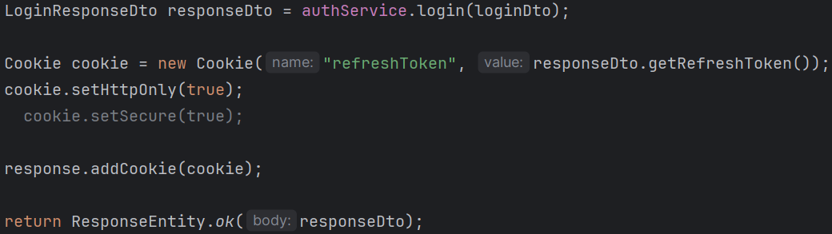
  - Just keep user id in the refresh token, no need to keep everything there.
  - 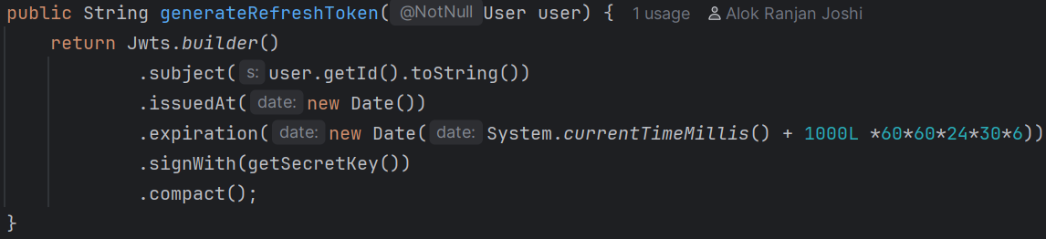
  - Login service method should get the user from principal not from database
  - 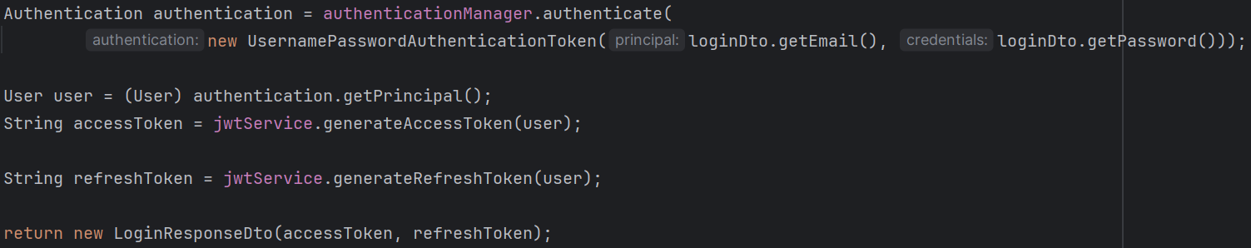
    - For this, user should be stored as principal instead of username.

- Frontend & Backend in Google OAUTH2 (in general)
- In case of “sign in with google”, There are 2 backends involved
  - Our own backend
  - Google’s backend
- After clicking on that “sign in with google” button, the frontend triggers one request which is:
  - GET /oauth2/authorization/google (this is our backend’s path; not google’s)
  - We don’t write this end point by our self; this is auto-created by Spring Security OAuth2 Client.
  - Internally it is handled by: OAuth2AuthorizationRequestRedirectFilter
- Now, our backend reads from application.yml file
  - 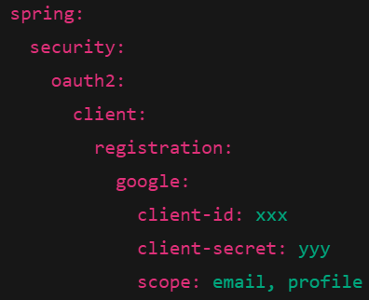
  - Now, our backend knows about:
    - which provider (google)
    - client_id
    - scopes
    - redirect_uri template
- Now, our backend will build a url having proper query parameters which will be sent as response to which the browser will redirect.
  - The URL will look something like this
  - 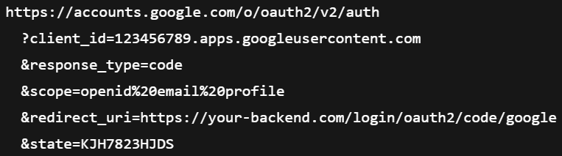
  - Note: redirect_uri is present in this URL.
  - Mark state and code here (code will be sent by google, state will be used to verify)

- Now, our Backend responds with one thing only
  - It is browser’s rule: If response status is 3xx and Location header is present → automatically navigate to that URL.
  - There is no involvement of frontend in this case.
- Now, the browser redirects to accounts.google.com …. page directly.
  - Here there is no role of our backend, it is completely backed by Google’s backend.
- Now, the user will interact with the google’s UI and give the necessary permissions of the required details.
- Then, Google will authenticate the user and redirect the browser to our backend’s path Using the same redirect_uri that your backend sent earlier
  - This full path (not just backend’s domain) is registered in Google console.
  - Note: state & code is present here.
  - NOTE ----------------------------------------------------------------------------------
  - So, in the Google Console you can register as many URIs you want, that will be treated as the allowed redirect URIs
  - And you need to pass the redirect_uri in the response so that google will get to know to which uri it has to redirect.
  - First Google will check if the given uri in the request URL is present in the access list, if present then it’ll redirect back to that URI after authenticating the user.

- Now, our backend’s end point “/login/oauth2/code/google” will receive the request.
  - This endpoint is ALSO auto-created by Spring Security OAuth2 Client
  - Handled by: OAuth2LoginAuthenticationFilter
- Now, our backend validate the state
  - state is a random, unpredictable value generated by YOUR backend before redirecting the user to Google.
  - 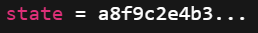
  - If the state matches, then continue; otherwise reject.
- Now our Backend exchanges code with tokens
  - code is an authorization code issued by Google after the user successfully authenticates and consents.
  - Think of it as a one-time, short-lived voucher that your backend can exchange for token.
  - Backend makes server-to-server call.
  - It sends client_id, client_secret, code, redirect_uri and receives access_token, id_token, expires_in
    - 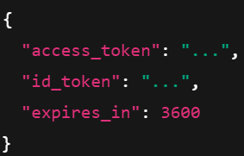
  - id_token is a JWT which contains the user details within it like the below
    - 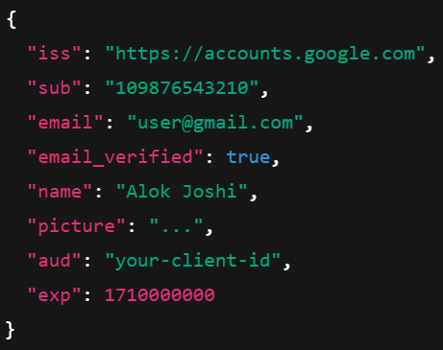
  - You only use the authorization code; the access_token is returned because OAuth requires it, but if you don’t call Google APIs, it is perfectly normal that it is never used.
- Now, you can implement the normal login in our backend after getting those details.
- In one sentence:
  - In Google OAuth login, the frontend only triggers navigation. The backend constructs the authorization request, redirects the browser to Google, and later receives the authorization code. Google authenticates the user, validates the redirect URI against its allow-list, and redirects back to the backend. The backend validates state, exchanges the code for tokens, extracts user identity, and then performs normal application login logic.
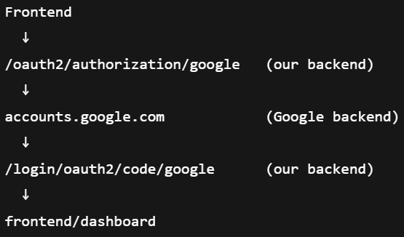
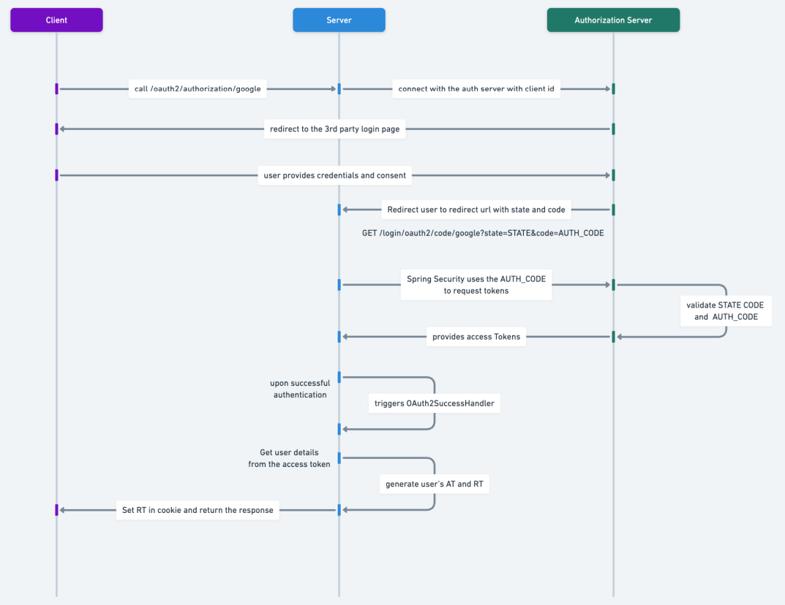
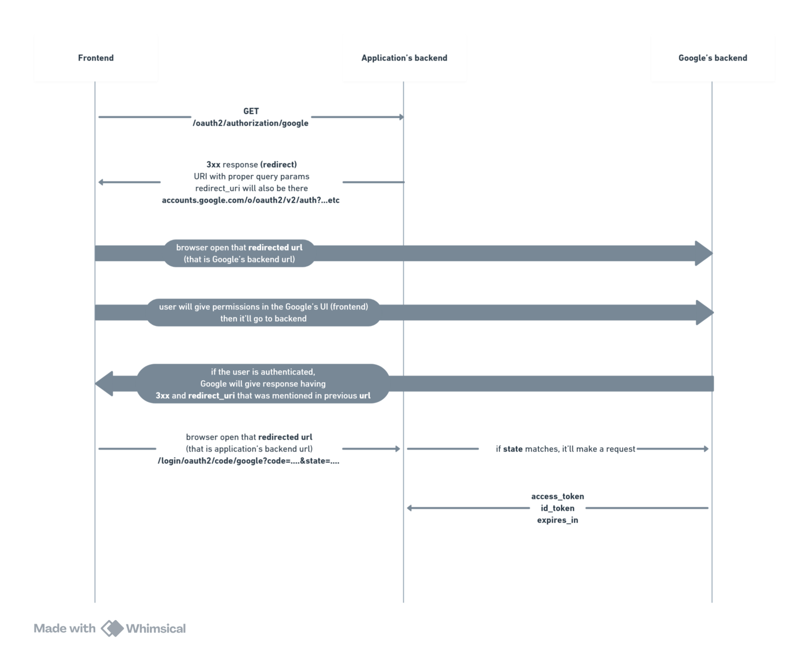
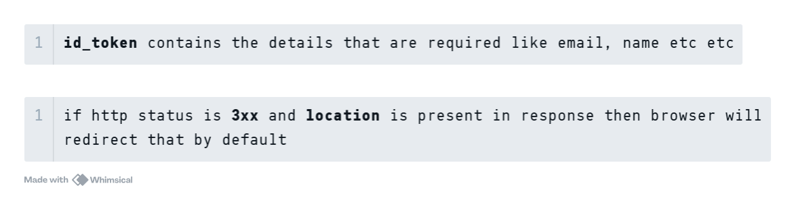

- Steps
- Google Console Setup
- Select the project in Google Console; and go to Dashboard
- API & Services >> Credentials
  - 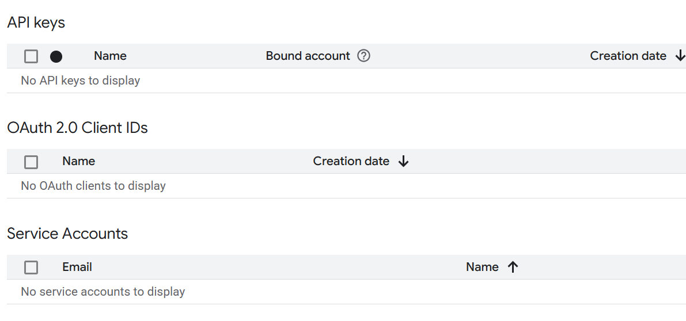
- Create Credentials >> OAuth Client ID
- Configure Consent Screen
  - You need to configure all the things separately.
  - Audience: either you can setup some test user or publish. Publish means anyone can try to login.
  - Data access: it is the scopes like which data do you want to access from google.
  - Clients: create the OAuth2 client;
    - 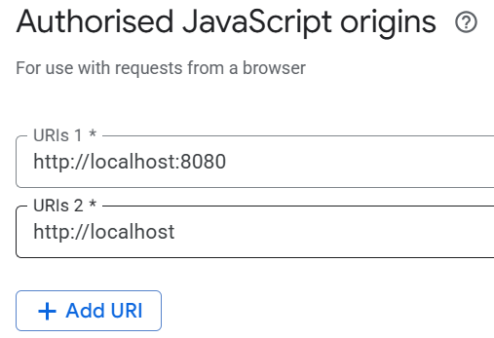
      - It means Requests coming from a browser whose origin is “http://localhost:8080” are allowed to start OAuth.
    - 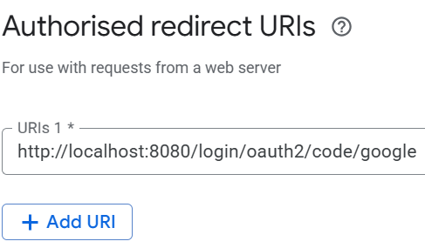(default URL of spring security)
- After creating the Client, you’ll get the client id and client secret, copy those and paste in the application.properties or application.yml file.
- ------------------------------------- Google Console set-up done -------------------------------------

Implementation in Spring Boot Application
- Add the oauth2Login filter in the custom filter chain
  - 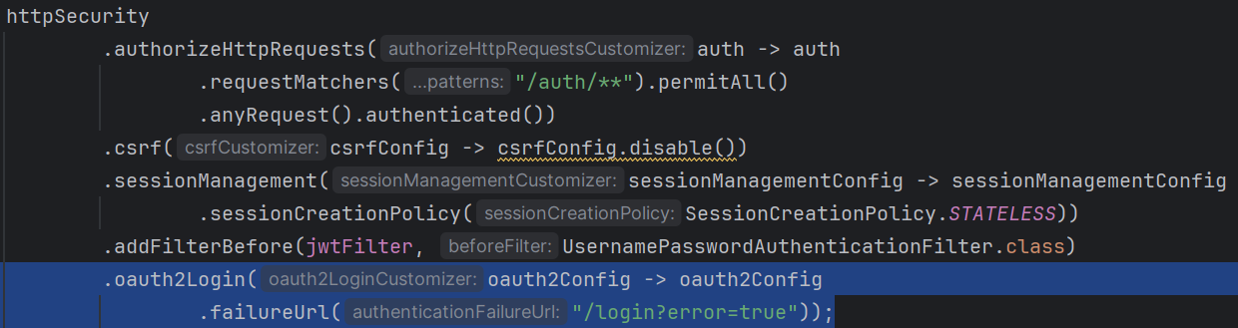
- You need to also add the success handler, otherwise even after getting the response from authorization server (google in our case) it’ll not do the required things after authenticating the user.
  - There is a class SimpleUrlAuthenticationSuccessHandler, that decides what to do after the authentication success.
  - Authentication can be of any type i.e. OAuth, Form login, Username/password login ..etc
  - This class contains one method onAuthenticationSuccess which is executed after the authentication gets succeeded.
  - So, if we create a Bean of a class extending SimpleUrlAuthenticationSuccessHandler class and overriding the method onAuthenticationSuccess then we can handle the authentication success case.
  - I created the below class:
    - 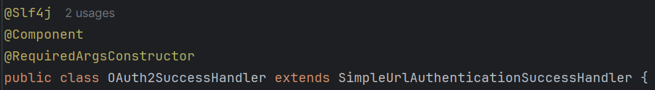
- Now just add that class’s object in the SecurityFilterChain
  - 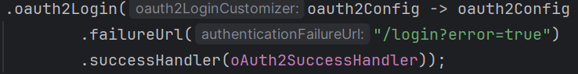

- I just checked if the user is present in the database, if present then do sign-up otherwise just create access and refresh token and send in response.
- 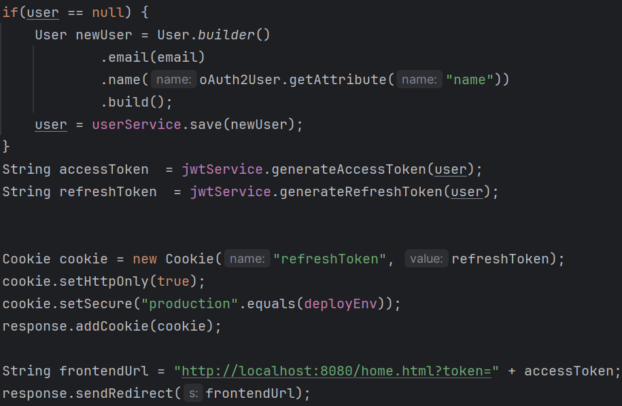
  - It is inside the onAuthenticationSuccess method.
  - response.sendRedirect() will send a redirect-response so that the browser will redirect to this specific url.
  - home.html is nothing but a static file.
- F

- OAuth2 flow in Spring Security
- There are 2 filters which are important:
  - OAuth2AuthorizationRequestRedirectFilter
    - backend to google before authentication
  - OAuth2LoginAuthenticationFilter
    - google to backend after authentication
- OAuth2AuthorizationRequestRedirectFilter consists of 2 things
  - One is to create the final object which is having state, client id, client secret, redirect uri etc etc every details that should be present in the request (for backend to google redirect).
    - This final object is of type OAuth2AuthorizationRequest
  - Another is to save that object while the control goes to google.
  - It generates the default oauth login end point, like /oauth2/authorization/google
  - 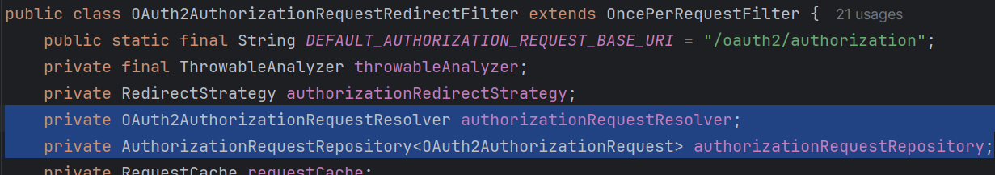
- There is a class called ClientRegistration,
  - It contains everything like clientId, clientSecret, registrationId (google, github ..etc), redirectUri
  - It doesn’t contains state because it is generated after starting the application after reading the application.yml or application.properties file.
  - Here redirectUri will be in format
    - “{baseUrl}/login/oauth2/code/{registrationId}"
    - 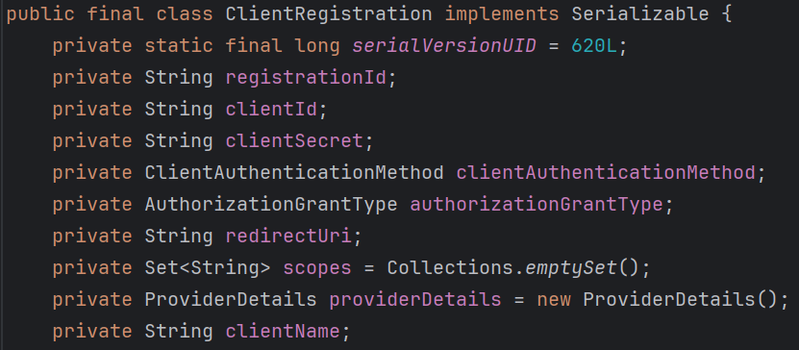

- The objects of ClientRegistration are stored in ClientRegistrationRepository.
  - InMemoryClientRegistrationRepository implements ClientRegistrationRepository is having one Map of registrationId to ClientRegistration
    - github : clientRegistration
    - google : clientRegistration
    - …. like this
- Now it comes OAuth2AuthorizationRequestResolver
  - It create objects of type OAuth2AuthorizationRequest using ClientRegistration object.
  - It contains state as well and remaining things that ClientRegistration contains.
  - Here the redirectUri will be in the form:
    - "http://localhost:8080/login/oauth2/code/google"
    - It is complete URL.
- Now, the final object is there, it just needs to be stored in a safe place for future use. AuthorizationRequestRepository is used to store that.
  - It doesn’t store in any map or list, it just store the AuthorizationRequest object in the session of the request object.
  - 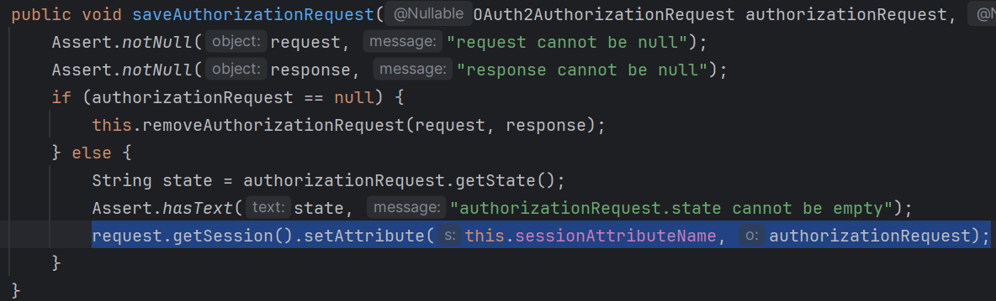
- Now, everything is done; our backend will send a redirect response to frontend, after seeing which the browser will redirect to that particular url (accounts.google.com .…)
- OAuth2LoginAuthenticationFilter
  - It contains an object of type AuthorizationRequestRepository and get the OAuth2AuthorizationRequest object from it.
  - It gets the response from OAuth2 provider and validate that with OAuth2AuthorizationRequest object, like state matching and all.
  - If any mismatch is there then it’ll reject that.
  - Then it create one token of type OAuth2LoginAuthenticationToken (just like UsernamePasswordAuthenticationToken in DaoAuthenticationProvider) and call the authenticationManager.authenticate() method.
  - Now just like username password authentication flow, this authenticate()method call delegates to AuthenticationProvider’s authenticate() method and here the AuthenticationProvider is OAuth2LoginAuthenticationProvider .
  - OAuth2LoginAuthenticatoinProvider is the one who exchange the code to get the tokens .
    - It is done with the help of DefaultAuthorizationCodeTokenResponseClient
- --------------------------------------------------------------------------------------------------------------
- Now, where is the filter that create the default login page for username password login form, oauth2 default login page.
  - The filter is DefaultLoginPageGeneratingFilter
  - It generates the default login pages.
  - 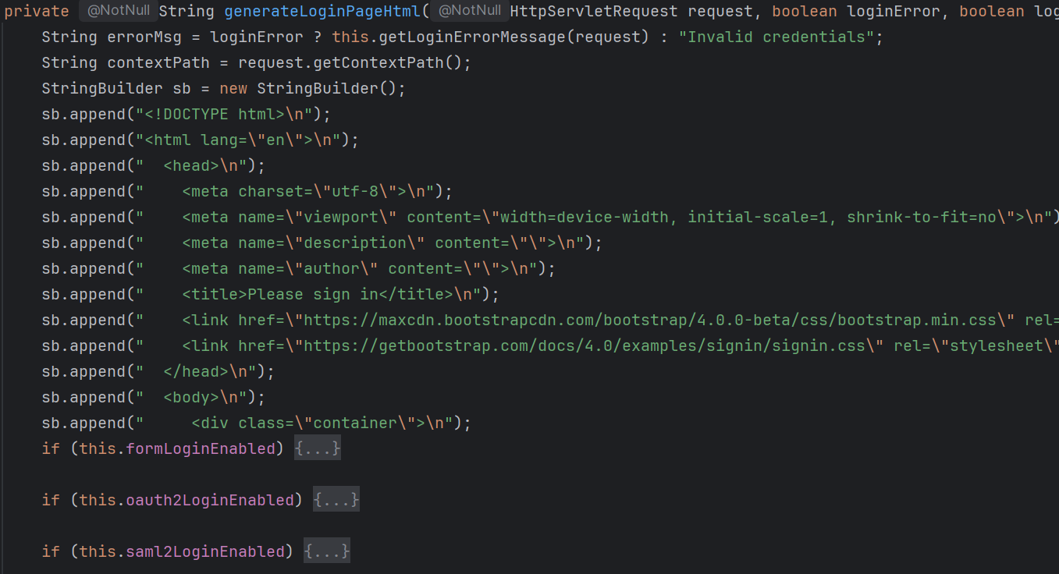
- NOTE ---------------------------------------------------------------------------------------
  - The redirected URIs are matches at the filter level, not servlet level. Spring Security is completely filter based.
  - 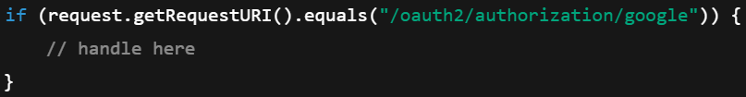

- OAuth2 work-flow in general (I am taking google as OAuth2 provider)
  - 2 backend are involved here: google’s backend, our application backend
  - first, when the signin with google (or any other provider) button is clicked in the frontend, it’ll call a GET request to Application Backend
    - in spring, this url is: oauth2/authorization/google
  - now, Application Backend creates a proper url having client_id, client_secret, redirect_uri, state etc etc.
    - note redirect_uri and state here, it’ll be used later....
    - that URL is send to the frontend with http status code 3xx (which is meant for redirect)
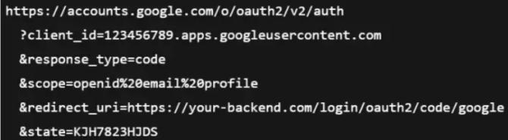
    - every browser's default behaviour is that it the response contains http status code 3xx and there is a location field there, then it'll redirect it to that location; there is no involvement of frontend here, its completely at the browser level.
  - now the browser will redirect to accounts.google.com/..... and user will get a screen to select the google account, and grant the consents.
  - After authenticating successfully, google will send a response (3xx and location) and location will contain that redirect_uri which was sent earlier.
  - so now, browser will redirect to that redirect_uri which goes to Application Backend.
  - this redirect_uri will be
    - “https://www.your-backend.com/login/oauth2/code/google?code=abc&state=xyz”
  - now this state will be checked, it should match with the state that was send to google before authentication.
  - if validation are successful, then application backend will use that code and make one POST request to google to get the tokens.

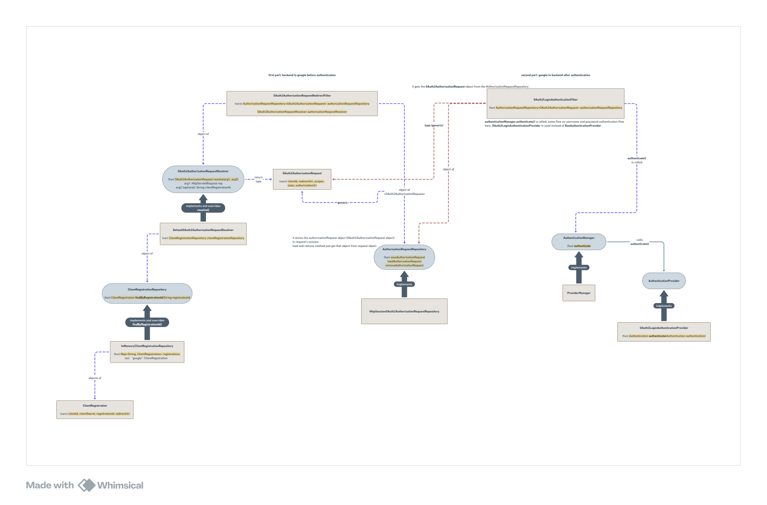
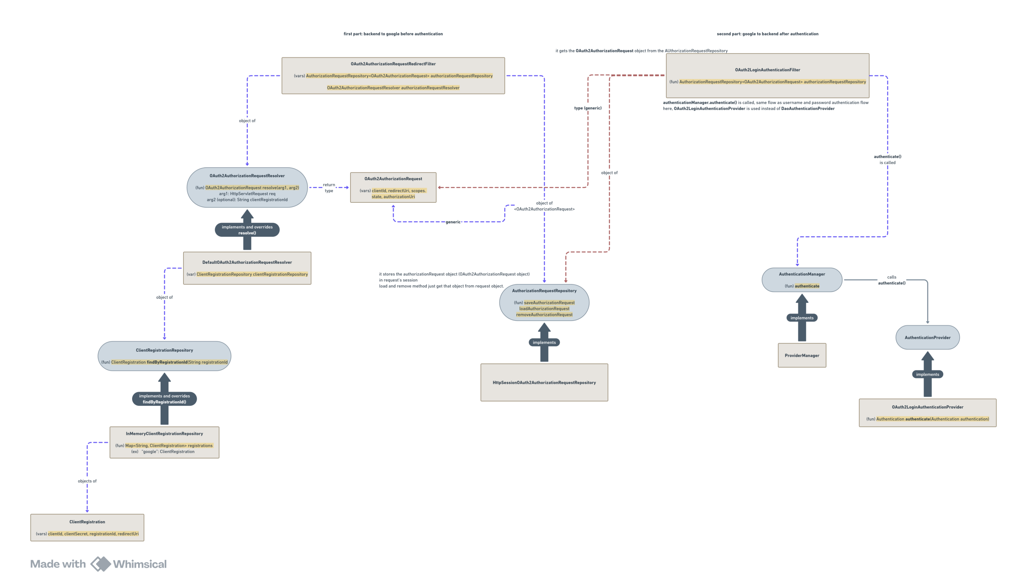
OAuth2 in Spring Security
- Part-1: application backend to oauth2 provider's backend
  - First the request come to OAuth2AuthorizationRequestRedirectFilter
  - It contains 2 parts:
    - one part builds the OAuth2AuthorizationRequest object (which is the final object which will be sent to oauth2 provider)
    - another part will save that object when the control goes to OAuth2 provider.
  - ClientRegistration is a class that contains all the details of the Client i.e. client id, client secret, registrationId, redirectUri etc; but it doesn’t contain the state.
    - here redirectUri is in the form: ”{baseUrl}/login/oauth2/code/{registrationId}”
  - There is a repository that stores all the ClientRegistration objects, which is ClientRegistrationRepository.
    - It contains a method findByRegistrationId which gives the ClientRegistration object for the particular registrationId (registrationId is nothing but “google”, “facebook”, “github”)
  - So, now we have all the objects os ClientRegistration, but we need to make the object proper to send in the request to OAuth2 provider.
    - because it has only templates kind of things. like you can see redirectUri is just a template, there is no state present here.
    - So, there is a resolver class which is named as DefaultOAuth2AuthorizatoinRequestResolver which takes the ClientRegistration object and create a OAuth2AuthorizationRequest object which contains fully ready values that can be sent to OAuth2 provider directly.
    - here state will be present.
    - here the redirectUri will be in the form of: "http://localhost:8080/login/oauth2/code/google"
  - Now, everything is completed, just the request has to be sent to OAuth2 provider; but we need to keep the object somewhere to validate after getting the response from OAuth2 provider.
    - So, there is a repository AuthorizationRequestRepository is there to store the OAuth2AuthorizationRequest object.
    - it doesn’t store those objects in any list or map, it just creates one attribute in the request object and store there.
- Part-2: oauth2 provider to application’s backend
  - OAuth2LoginAuthenticationFilter is the first filter in this case.
  - it gets the OAuth2AuthorizationObject from the AuthorizationRequestRepository .
  - then it validate the details from the response of OAuth2 provider with the OAuth2AuthorizationObject, for example state will be checked.
  - if any mismatch is there, then it’ll reject it.
  - after that it’ll simply call the authenticate() method of authenticationManager, just like we do in case of username and password authentication.
    - here the authentication token will be of type: OAuth2LoginAuthenticationToken
  - then this authentication() method call will be delegated to AuthenticationProvider’s authenticaion() method and in case of OAuth2, the AuthenticationProvider is OAuth2LoginAuthenticationProvider.
  - this OAuth2LoginAuthenticationProvider exchange the code that was gotten from OAuth2 provider’s response and get the tokens like id_token, accessToken etc etc.
  - this id_token contains the necessary details about the user that we want like username, email etc etc.
  - after that it just store the authentication object in security context and we can get the details using getPrincipal() method just like username and password authentication.

- Authorization
- @ElementCollection
  - If we write this annotation on a field inside the entity, it’ll create a separate table in database and store those.
  - It is only used in case of collections like list, set ..etc.
  - You can say it is like one-to-many relation type, but that’s not correct;
    - In case of relation (one-to-many or many-to-one), both the entities are having their own primary keys, but in this case, the field that is being stores as a collection is not having any primary key.
  - Relation are created where both the entities are independent and both are having their own primary keys, but @ElementCollection just store the values not the new entity.
  - 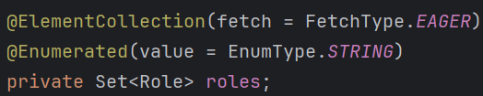
  - Here Role is just a enum, not an entity and it doesn’t have its own identity.
  - 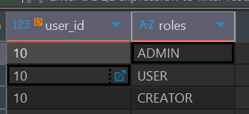
  - It is the user_roles table which is created due to @ElementCollection, it doesn’t have any primary key; it just map the user_id to a particular value.
  - As I have set @Enumerated here for EnumType.STRING, so the values are being stored in the database; otherwise the ordinals i.e. 0,1,2,… would have been stored.

- Role is the main concept for authorization. Depending upon the role of the user, it’ll be decided that what are the thing he/she can access.
- We can the particular routes as authorized for some particular type of users
  - 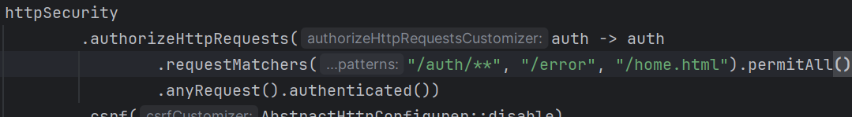
    - Here we are simply writing permitAll and remaining request as authenticated.
- 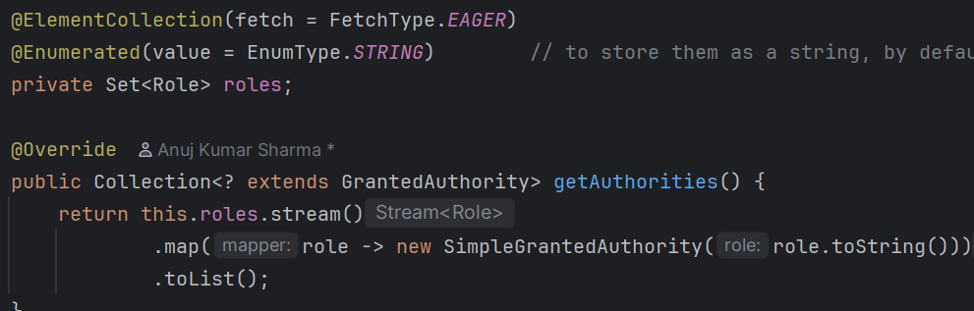
  - Here just return the SimpleGrantedAuthority type of object.
  - Because the return type is something that extends GrantedAuthority and SimpleGrantedAuthority is the basic implementation of GrantedAuthority.
- In the JWT filter while creating the UsernamePasswordAuthenticationToken, make sure to set the authorities field, otherwise no user will be having any authorities.
  - Spring Security calls auth.getAuthorities() (auth is the Authentication object) and validate the authorities.
- You can also set authorization for different type of request i.e. GET, POST, ..etc
  - 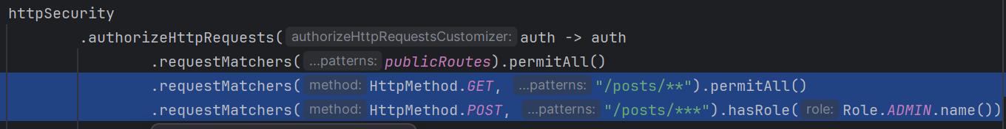
- F

- The flow happens like the below
  - AuthorizationFilter is the first one that comes in case of authorization.
  - Just like AuthenticationManager, one interface AuthorizationManager is also there that contains one method check()
  - AuthorizationFilter is having the method doFilter which calls this check() method of AuthorizationManager
  - The class RequestMatcherDelegatingAuthorizationManager implements AuthorizationManager passing the generics as HttpServletRequest so it get called.
  - After this, check() method of this RequestMatcherDelegatingAuthorizationManager calls the check() method of AuthoritiesAuthorizationManager (it is another child class of AuthorizationManager and it implements marking the generics as Collection<String>) and here the authorities are checked.
  - 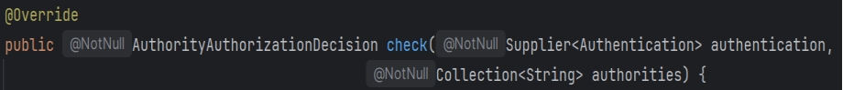
    - It gets the authentication object and authorities
    - Here authorities means the authorities required to access the route.
    - It’ll fetch the authorities from the authentication object, and check if any of those authorities is present in the required authorities list.

- F

- hasRole vs hasAuthorities
  - hasRole(“ADMIN”) is just a syntactic sugar for hasAuthorities(“ROLE_ADMIN”)
  - If you are storing the roles with the prefix ROLE_ then hasRole() is handy.
  - For example: ROLE_USER, ROLE_ADMIN … are the roles present inside database.
    - Here we can just write hasRole(“USER”) --- it’ll automatically add the prefix ROLE_ and check i.e. it’ll be checked as ROLE_USER.
    - If you write hasAuthorities(“USER”) then it’ll be checked as USER only.
- Role is kind of top-level authorization like which type of user can access what. Authority is bottom level authorization, like more granular authorization.
  - Lets suppose USER, ADMIN are the roles.
  - USER can view the things, you can give it the authorities like VIEW_POST, VIEW_USER
  - ADMIN can do everything, so you can give it the authorities like CREATE_POST, DELETE_POST etc etc.
  - In simpler terms, role is top level permissions; after role authorities decide the low level permissions.
- I created one Authority enum and implemented the below:
  - 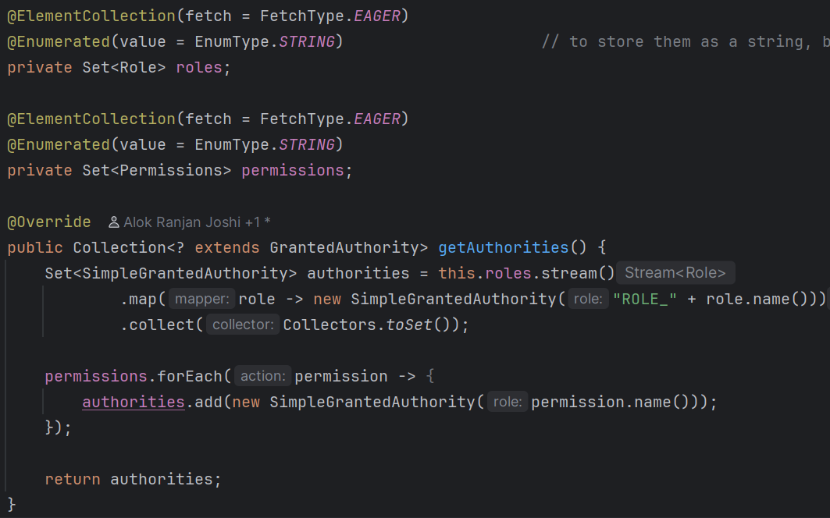
  - 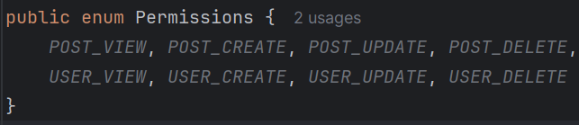
- Now you have to add those authorization in the custom filter chain
  - 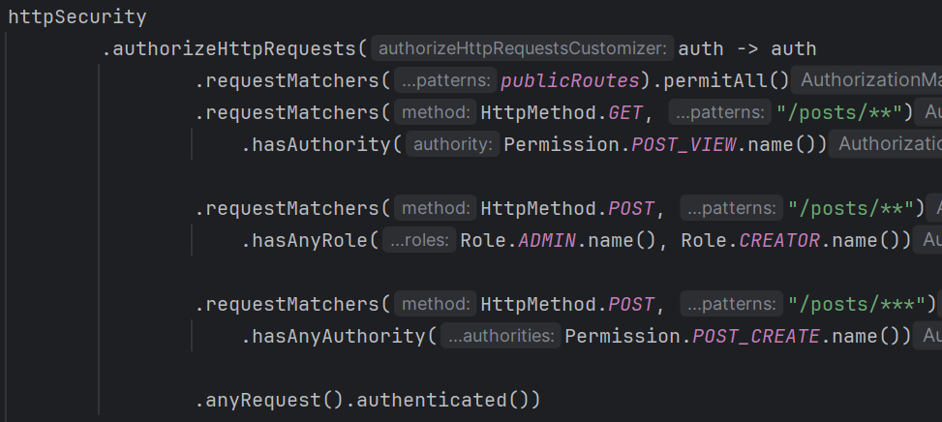
  - You can write hasAuthority() or hasAnyAuthority() and hasRole() or hasAnyRole() with the same requestMatchers(), you need to write one requestMathcer() for role or authority.
  - You can give multiple authorities like this way.
- Otherwise you can create a hard-coded maps of roles with permissions like some particular role user can have some particular set of permissions.
  - 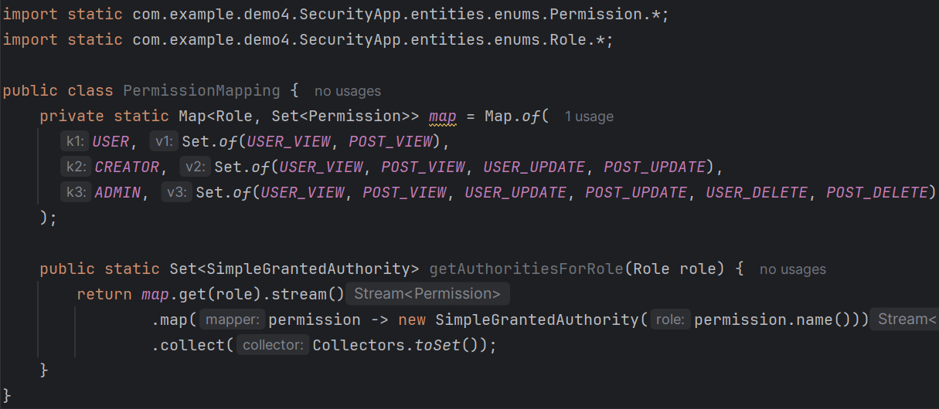
  - NOTE: You can import enum values directly using import static
  - Now you don’t need to store the permissions in the database.
  - 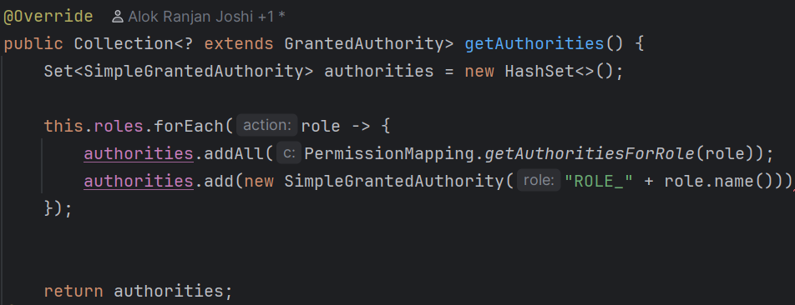

- As we can see, writing this many logic in the WebSecurityConfig is creating overhead and messy.
  - In case of real world project, there will be so many paths, roles, permissions and if we write all those authorization then it’ll be very complicated.
  - Therefore @Secured and @PreAuthorize and @PostAuthorize are used.
  - These are used for method level authorization, we just need to write these with the methods.
  - @EnableMethodSecurity is required to use these annotations. Just write once on any Component class (you can write with any class having @Configuration or @Component)
  - For using @Secured, you need to write
    - 
  - For using @PreAuthorize or @PostAuthorize, you need to write
    - By default prePostEnabled is true only, so even if you don’t mention this explicitly, it’ll work.
- @Secured
  - It’ll only work for roles, i.e. having ROLE_ prefix.
  - It’ll not work for any other permissions like POST_VIEW, POST_DELETE etc etc.
  - ROLE_ must be there otherwise it’ll not work.
  - 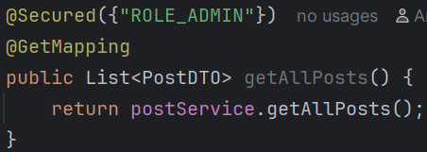
    - Now the users having roles other than ADMIN will not be able to access this.
  - NOTE: You need to write ROLE_ADMIN here, only ADMIN will not work.
  - 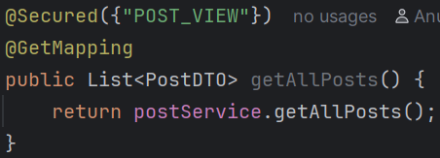
    - I wrote this POST_VIEW and tried to access the posts from the user who has POST_VIEW permission. But it didn’t work.
  - So, permissions having prefix ROLE_ will only work in case of @Secured
- @PreAuthorized
  - It is widely used; @Secured is used very rarely (negligible)
  - It can access the arguments of the method.
  - It supports role, permissions, conditions (and, or etc), parameters (method arguments)
  - You can write hasRole, hasAnyRole, hasAuthority, hasAnyAuthority …etc etc inside it.
  - 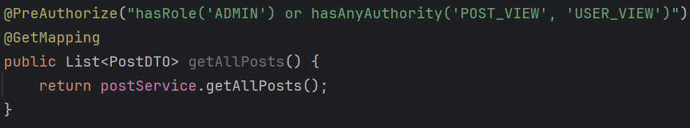
    - We can write the query like this. You can use and or or and write multiple filters (authorizing filters; not spring filters…) here.
  - 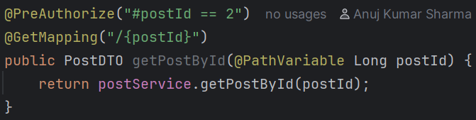
    - You can also access the method arguments using #
    - In here I accessed postId using #postId
  - Also you can access authentication object inside @PreAuthorize.
    - 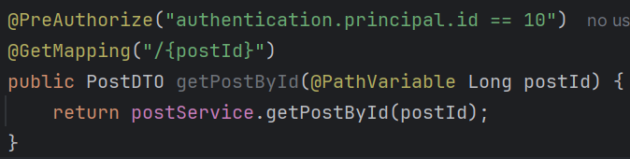
    - NOTE: here don’t make getter function call;
    - Just write authentication.principal.id or something like that.
    - But, if the authentication is null, then it’ll fail silently.

- You can also create Security service for authorization; and it is recommended.
  - I want to display the post that was searched by postId, only if the user is the author of this post.
  - 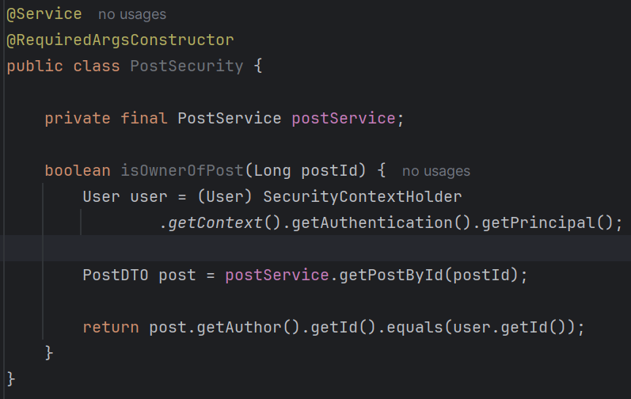
    - Created one service PostSecurity and wrote this method inside that.
  - 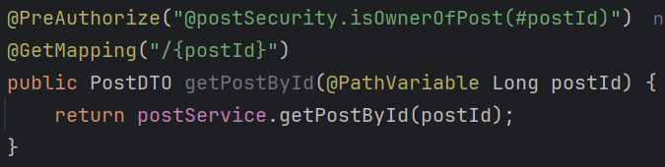
    - The bean of PostSecurity can be accessed by @postSecurity inside the @PreAuthorize , and the argument postId can be accessed as #postId
    - p will be small in @postSecurity because the bean name will be postSecurity by default.
- You can write @Secured, @PreAuthorize, @PostAuthorize anywhere; but it is the best practice to use those at controller level; because in case of unauthorized condition, the control should not even go to the method.
- F
- F
- F
- F
- F
- F
- F
- F
- F
- F
- F
- F
- F

